Knowledge
- A group changes in quantity when something is added to it
- Addition starts with the largest quantity first
- Count on from the largest quantity adding on the smaller quantity
- Find the total
- When adding 2 digit numbers add the ones first then the tens
- If you need to cross the boundary you need to exchange up or down:
- Exchanging up – exchanging ten ones for a ten
- Exchanging down – exchanging a ten for ten ones
Vocabulary | Definitions
Add | Putting two or more groups together
Greater | More
Sum | The total of adding two or more numbers together
Quantity | The value of a number e.g. 3 and 5, 5 is the largest quantity
Increasing | The number is going up in quantity
Altogether | How many objects when all groups have been added together
Partition | To divide into parts
Tens | How many tens a number has within its value
Ones | How many ones a number has within its value
Exchanging | Exchanging a ten for ten ones or ten ones for a ten
Total | The value when two numbers have been added together

Addition
+
4
555

5 6

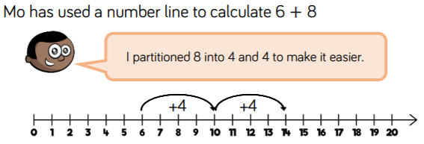

+10
+10
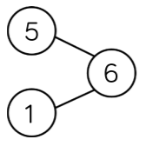

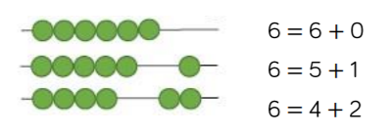
34 44 54

