Knowledge
- Halving is sharing into two equal groups. It is the opposite of doubling.
- When we share into equal groups we use the one for me, one for you method until all of the initial quantity has gone.
- When we share we focus on how many each group can have
- When we group, the focus is how many groups we can make.
- When we group the unit of measurement is different from the starting unit of measurement
e.g. 6 stickers with 2 stickers in each group = 3 groups
started with stickers as the unit of measurement, now the unit of measurement is how many groups
Vocabulary | Definitions
Halve | Splitting into two equal groups
Equal | Same as
Share | Split into equal groups
Quantity | The value of a number e.g. 3 and 5, 5 is the largest quantity
Divide | Share into equal groups
Equal groups | Groups of the same quantity
Multiple | A quantity that can be divided by another quantity without leaving a remainder
Remainder | How many left over that cannot be shared to create equal groups

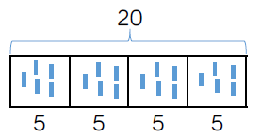

Division

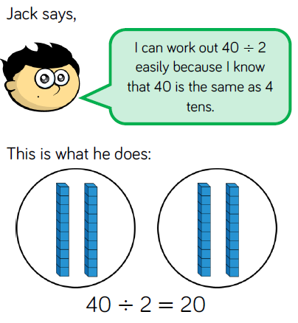
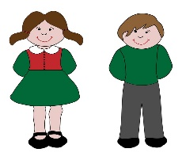
4 equal groups of 3
Remainder 1
4 equal groups of 3
12 divided by 3
13 divided by 3
6 stickers shared equally to 2 children
6 divided by 2 is 3

