Fractions | Halving | Finding half of a shape | Finding a quarter of a shape | Finding half/quarter of a quantity | Understanding equivalence
Skill – Practical/Fluency | e.g. A lady bird has 6 spots on its back. Share them equally between both sides.  e.g. half of 6  This can also be represented using numicon. | Finding a half of a shape by splitting into two equal sections e.g. down the middle  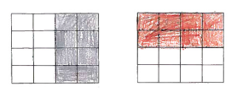  This can then be developed further to represent a half in a different way e.g.  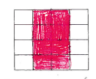 | Finding a quarter of a shape by splitting into four equal sections e.g. into 2 and into 2 again  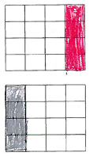  This can then be developed further to represent a quarter in a different way e.g.  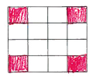 | e.g.  4  4  2  2  e.g a half of 4 is 2  Children to understand that fractions are a written representation of division and that halving is equivalent to dividing by 2.  The same for dividing into quarters as this is equivalent to dividing by 4 e.g. halving and halving again. | e.g. understanding  1/2 is the same as 2/4  3/4 is the same as 3 lots of 1/4
 | Halving | Finding half of a shape | Finding a quarter of a shape | Finding half/quarter of a quantity | Understanding equivalence
Vocabulary | Half  Equal  Same  Split | Half  Equal  Same  Split  Equal parts  Fraction | Quarter  Half  Equal  Same  Split  Equal parts  Fraction | Quarter  Half  Equal  Same  Split  Equal parts  Fraction | Quarter  Half  Equal  Same  Split  Equal parts  Fraction  Equal to  Equivalent
Skill – Knowledge  (Address this knowledge through taught input and diagnostic questioning) | - Understanding that halving is sharing into 2 groups equally  - Understanding of equivalence  - Understanding that halving is splitting down the middle into 2 | - Understanding that halving is sharing into 2 groups equally | - A quarter is a whole that has been halved and halved again  - Understanding that a quarter is sharing into 4 equal groups | - Applying learning to shapes to quantities | - Understanding language of equal to  - Identifying equal groups
Skill - Evaluation | Evaluate learning through REACH questioning and evidence of mathematical vocabulary in pupil voice and responses

