Knowledge
- Halving is sharing into two equal groups. It is the opposite of doubling.
- When we half a shape we split it into two equal sections.
- A half is 1 equal part of 2
- When we find a quarter we have to half and half again.
- A quarter is 1 equal part of 4
Vocabulary | Definitions
Half | 1 equal part of 2
Equal | Same as
Share | Split into equal groups
Quantity | The value of a number e.g. 3 and 5, 5 is the largest quantity
Divide | Share into equal groups
Equal part/group | Group of the same quantity  Part of a shape equal and identical to the other parts
Fraction | A part of a whole
Quarter | 1 equal part of 4

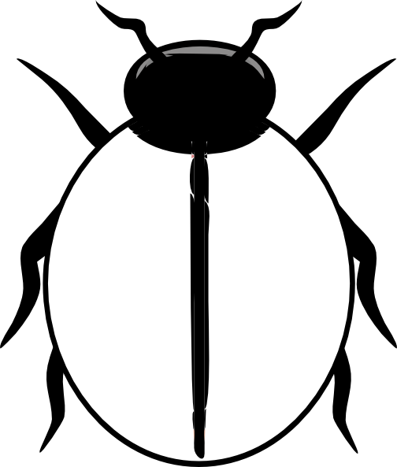

4
Fraction

Equivalence
Half of a quantity
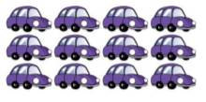
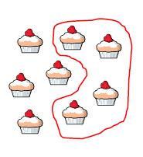
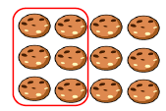
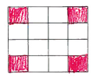
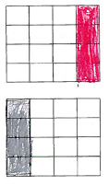
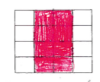
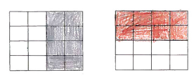
2 quarters
2/4
Is the same as
1 half
1/2
Quarter of a quantity
2
2
4
Quarter of a shape
Half of a shape

