Mathematics
EYFS
Aims:
Playing and Exploring/Engagement
- Finding out and exploring
- Playing with what they know
- Being willing to 'have a go'
Active Learning/Motivation
- Being involved and concentrating
- Keeping trying
- Enjoying achieving what they set out to do
Creating and Thinking Critically/Thinking
- Having their own ideas
- Making links
- Choosing ways to do things

Intent | Implementation | Impact
In EYFS at Girnhill Infant School we provide a stimulating and high quality Mathematic Early Years Curriculum by ensuring challenging and playful opportunities. We understand the need for high quality environments and meaningful interactions, which enable children to develop their mathematical thinking and talk.  We are ambitious in our expectations of all pupils, ensuring strong cross curricular links are made to develop children holistically:  - Children will be introduced to mathematic subject specific vocabulary that a mathematician would use.  - Children will learn, work and talk like a mathematician.  - Children will be fluent in the fundamentals of mathematics and be able to apply this learning to a variety of everyday situations.  - Children will be exposed to a range of reasoning and problem solving opportunities to encourage children to justify, interpret and explain their understanding using taught mathematical vocabulary.  Planning:  Maths is planned using White Rose Maths Hub coverage and maths skill progression grids ensuring considered sequence of experiences including key vocabulary and knowledge.  Concepts taught in mathematics follow a concrete, pictorial and abstract approach so that children can actively learn with visual supports.  Curriculum:  They count reliably with numbers from one to 20, place them in order and say which number is one more or one less than a given number.  Using quantities and objects, they add and subtract two single-digit numbers and count on or back to find the answer. They solve problems, including doubling, halving and sharing.  Research:  Closing the vocabulary gap:  - Between birth and 48 months, professional parents speak 32 million more words to children than those from disadvantaged families – herein lies the vocabulary gap.  - Vocabulary size at 28 months equates to linguistic and cognitive ability at age 8.  - Vocabulary at 5 – 7 is a direct predictor of comprehension 10 years later.  - Language and vocabulary are vital skills in enabling children to understand Mathematical concepts and critically evaluate their mathematical problems.  Rosenshine’s principles in action:  - Conceptual information initially enters our working memory. Working memory is rather small and only small amounts of information can be absorbed at once. New information is only moved from working memory to long-term memory if we can connect it to knowledge that we already have (our schema). As a result of this, prior knowledge is a major factor in our capacity to learn new information therefore a specific teaching sequence needs to be implemented based upon daily, weekly and termly review.  - A specific teaching sequence is fundamental in Mathematics in order to help children ‘know more and remember more’. Children need to be able to move fluently between representations of mathematical ideas. High quality teaching should enable children to make rich connections across mathematical ideas. | Our mathematics curriculum enables children to become a developing mathematician through high quality provision, which includes:  Teaching sequence:  Planning and delivery follows Rosenshine’s Principles in action –  - Daily review in the form of Flashcards of vocabulary  - Present new material in small steps using the Mathematics progression grid, breaking down large objectives into small manageable chunks of learning and introducing new language.  - Ask questions which are appropriately pitched and offer a varying degree of complexity in order to meet need and address misconceptions.  - Provide models such as worked examples of written models of calculation, mental arithmetic strategies in order to solve problems.  - Guide student practice of mathematic skills through verbal feedback.  - Check for pupils understanding of concepts through the use of questioning and diagnostic tools.  - Obtain a high success rate  - Provide scaffolds for different tasks through the use of concrete resources and pictorial representations  - Independent practice  - Weekly and monthly review through the use of learning journeys and flashcards of vocabulary.  Provision & Resources:  Children have a range of maths and non-maths equipment readily available to explore and investigate within their environment.  Staff Knowledge:  Staff have produced and developed EYFS next steps skills progression for number and shape space and measure. These are evident in provision and support staff in resourcing, enhancing and providing children with necessary learning opportunities to move learning forwards. Children are monitored and tracked against the same criteria.  Teaching:  Children are taught the fundamental skills in mathematics through explicit taught sessions.  Children are taught to practise, use and apply these skills independently and collaboratively throughout their learning environment.  Children develop their mathematic subject specific vocabulary through explicit teaching of maths vocabulary and definitions.  Children develop understanding of mathematical key concepts and vocabulary through exposure to a range of fiction and non-fiction subject specific texts.  Maths blast takes place daily focusing on the fundamental principles of mathematics.  Learning Environment:  Learning environments and working walls focus on the skills and subject specific vocabulary. Children use these to support their learning and development.  Assessment:  Mathematics is assessed through half-termly teacher assessment against the ELG’s. This is evidenced in children’s learning journeys through: photographic demonstration of skill, pupil voice focusing on the mathematical terminology and written evidence of mathematical learning. | Outcomes:  Children demonstrate their understanding of key vocabulary through pupil voice evident during lesson observations and working folders. Pupil voice focuses on the ‘knowing more and remembering more’ principle.  From monitoring this demonstrates that:  - Children are introduced to mathematic subject specific vocabulary that a mathematician would use and can use this confidently.  - “(talking about what happens to the total in addition) the quantity gets greater when we add more.”  - Children will learn, work and talk like a mathematician.  - (talking about what happens to the remaining quantity in subtraction) “the quantity is decreasing.”  - Children will be fluent in the fundamentals of mathematics and be able to apply this learning to a variety of everyday situations.  - “I know that 2 + 3 is 5 so 3 + 2 is 5.”  - Children will be exposed to a range of reasoning and problem solving opportunities to encourage children to justify, interpret and explain their understanding using taught mathematical vocabulary.  - “Tom needs 6 because 1 more than 5 is 6.”

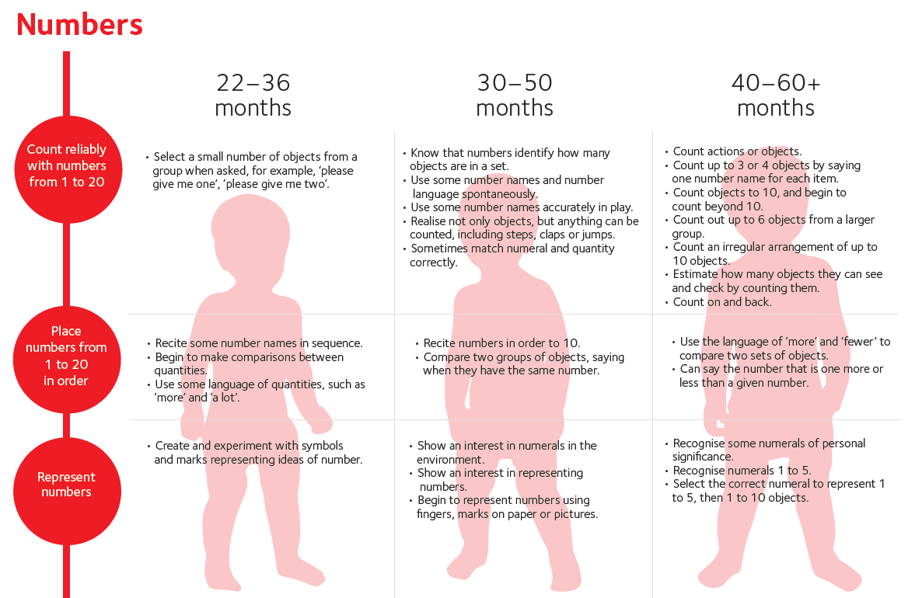
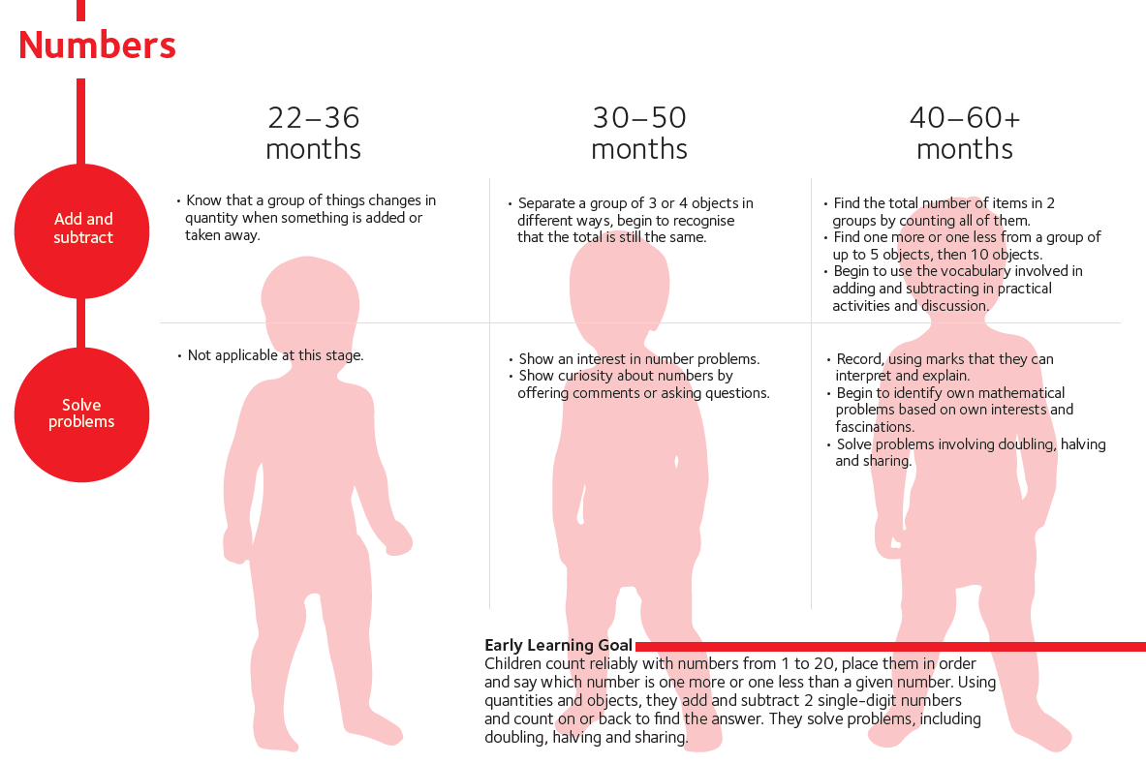
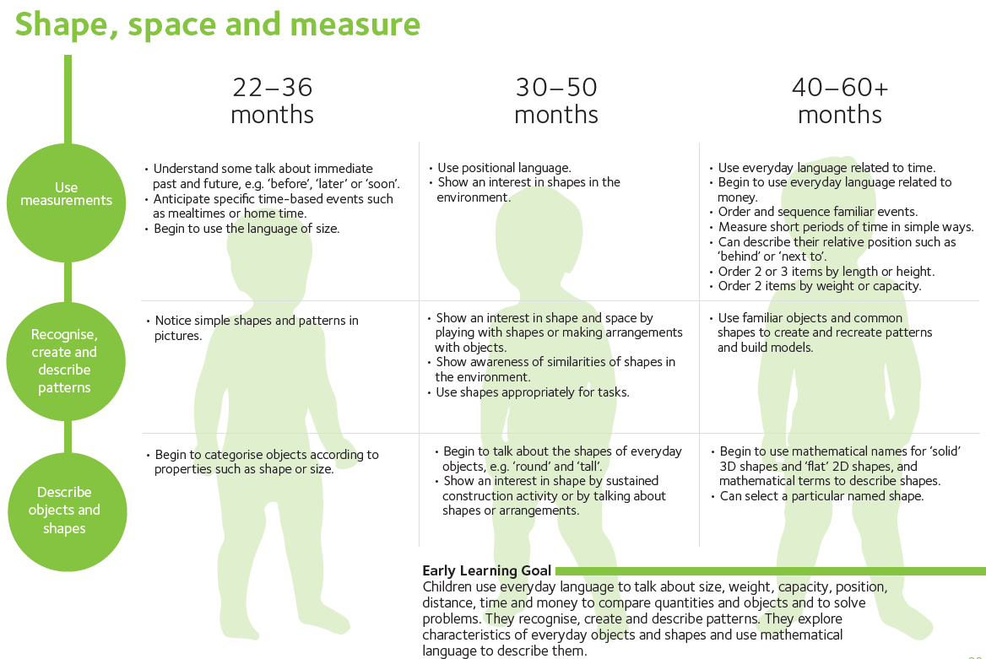
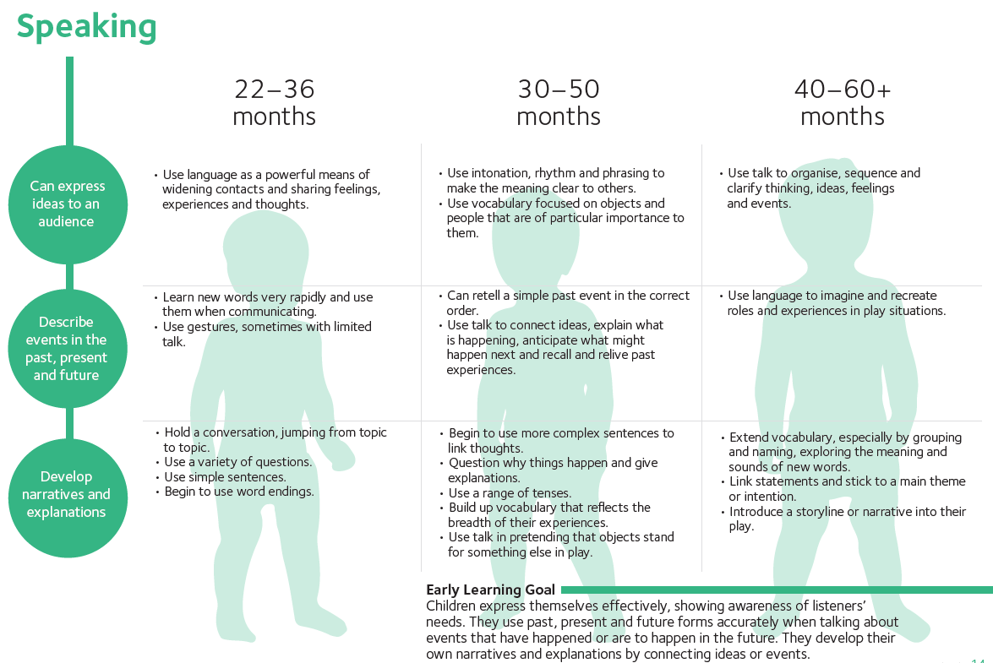

Objective: To recognise and order numerals
Initial |  |  |  |  | Final
Use number names spontaneously in play  Reciting number names in order to 10 | Recognising some numerals of personal significance e.g. age or house number | Recognising numerals 1 to 5  Placing numerals 1 to 5 in order | Recognising numerals 1 to 10  Placing numerals 1 to 10 in order | Recognising teen numbers 11 – 20  Placing teen numbers in order, following on from 1 - 10 | Understanding numbers can be ordered forwards and backwards (ascending and descending order) e.g. 1,2,3,4,5 or 5,4,3,2,1

Objective: To accurately count a range of items
Initial |  |  |  |  | Final
Knows that a number identifies how many objects are in a set e.g. points to objects and spontaneously uses number names | Begins to count 3 or 4 objects, inaccurately, but reciting number names in correct sequence e.g. touching 3 objects and saying 1,2,3,4,5,6 | Begins to count 3 or 4 objects saying one number name for each item  e.g. touching 3 blocks saying 1,2,3 | Accurately counts up to 10 objects/claps/ jumps using 1:1 correspondence (touch counting) and beyond 10 | Accurately counts an irregular arrangement of objects e.g. bears in a huddle rather than a line | Counting by estimating how many objects and checking with 1:1 correspondence

Objective: To use language of more and less
Initial |  |  |  | Final
Simple language of quantities  e.g. more, a lot, lots etc | To use language of more/less/fewer to compare two sets of objects | Says the number that is one more than a given number (with visual support e.g. number line) | Find one more or one less from a group of objects (1-10) | Say one more or one less than a given number 0 – 20

Objective: To add two quantities together
Initial |  |  |  | Final
To be able to represent a number e.g. show 2 fingers when someone says 2  To be able to accurately touch count a group of objects | To be able to use vocabulary of addition e.g. more, greater, plus, add, together, combine, altogether, sum and apply this accurately when comparing quantities | Find the total number of items in 2 groups by counting how many altogether | To add 2 quantities together by counting on from the largest quantity e.g. knowing 4 is 4 and counting on the second quantity | To be able to apply the skill of addition by solving a mathematical problem

Objective: To subtract one quantity from another
Initial |  |  |  |  | Final
To be able to represent a number e.g. show 2 fingers when someone says 2  To be able to accurately touch count a group of objects | To be able to use vocabulary of subtraction e.g. less, fewer, subtract, take away, minus and apply this accurately when comparing quantities | Find the largest quantity from a group of two quantities  e.g. know that 4 is greater than 2 | To subtract 1 quantity from another by taking away and counting how many are left | To subtract 1 quantity from another by counting back using a number line | To be able to apply the skill of addition by solving a mathematical problem

Objective: To double
Initial |  |  |  |  | Final
To be able to represent a number e.g. show 2 fingers when someone says 2  To be able to accurately touch count a group of objects | To be able to use vocabulary of doubling e.g same | To be able to visualise doubling by recognising symmetry e.g. butterfly, ladybird etc  Matching two objects by shape, size, colour etc | To be able to add 2 of the same quantity by counting how many altogether e.g. 4 + 4 | To be able to add 2 of the same quantity by counting on e.g. 4 + 4, 4, 5,6,7,8 | To be able to recall doubles independently

Objective: To halve
Initial |  |  |  | Final
To be able to recognise that we can separate a group of objects in different ways | To be able to accurately touch count a group of objects | To be able to use vocabulary of halving e.g. sharing, equally, same to each group etc | To be able to share a group of objects equally into two groups by using the one for me, one for you method until all objects have gone and counting how many objects are in each group | To be able to recognise that halving is the inverse of doubling and apply knowledge of doubles to calculating a half.

Objective: To recognise, name and describe shapes
Initial |  |  |  | Final
To use shapes in every day play and talk about these  Beginning to talk about the shapes of everyday objects e.g. round and tall | To use shapes appropriately for tasks e.g. knows to use a round circular shape for a wheel on a vehicle | To name some shapes | To use mathematical terminology to name 2D and 3D shapes | To use mathematical terminology to name and describe the characteristics of 2D and 3D shapes e.g. vertices, faces, edges

Objective: To use language of length and height
Initial |  |  |  |  | Final
To begin to use simple language of size to talk about the shapes of everyday objects e.g. tall, short | To order 2 or 3 objects by length or height | To use everyday language of length/height (tall, taller, tallest, short, shorter, shortest, long, longer, longest) to compare and describe objects | To solve problems using the language of length and height | To estimate length/height and begin to measure using a variety of equipment e.g. cubes, links, rulers | To calculate the difference and describe and compare lengths and height using accurate measurements  e.g. the pencil is 2 cubes taller than the crayon
Objective: To use language of weight
Initial |  |  |  |  | Final
To begin to use simple language of weight to talk about the shapes of everyday objects e.g. heavy, light | To order 2 or 3 objects by weight | To use everyday language of weight (heavy, heavier, heaviest, light, lighter, lightest) to compare and describe objects | To solve problems using the language of weight | To estimate weight and begin to measure using a variety of equipment e.g. scales, pan balance etc | To calculate the difference and describe and compare weight using accurate measurements  e.g. the stone is 2 cubes heavier than the block
Objective: To use language of capacity
Initial |  |  |  |  |  | Final
To play and explore early capacity in the sand/water area e.g. filling and emptying containers |  | To order 2 items by capacity |  | To use the language of capacity (full, fuller, fullest, empty, emptier, emptiest) to compare and describe objects |  | To solve problems using the language of capacity
Objective: To use language of time
Initial |  |  |  |  |  |  | Final
Anticipates time based events e.g. dinner time, home time etc | Understands vocabulary associated with past and future e.g. before, later, soon |  | Measures short periods of time in simple ways |  | Orders and sequences familiar events e.g. key text, daily routine and use the language of time to describe this |  | To use the language of time to compare and describe events

Objective: To use language of position and direction
Initial |  |  |  | Final
To practically demonstrate in provision use of preposition e.g. climbing over something or putting train under a bridge etc | To use the positional language to describe the placement of an object | To describe relative position e.g. next to, behind, in front of, on top of | To use positional and directional language to compare and describe objects | To solve problems using language of position and direction

Objective: To use language of money
Initial |  |  |  | Final
To explore in provision everyday money | To begin to use everyday language of money e.g. pounds, pence, coin, note, penny, change, costs | To recognise and know denominations of coins e.g. 1p, 2p, 5p, 10p, 20p | To be able to compare and describe amounts using language of money  e.g.  the bus costs more than the dog  20p is worth more than a 2p | To be able to solve problems using the language of money

Mathematics
KS1
Aims:
- become fluent in the fundamentals of mathematics, including through varied and frequent practice with increasingly complex problems over time, so that pupils develop conceptual understanding and the ability to recall and apply knowledge rapidly and accurately
- reason mathematically by following a line of enquiry, conjecturing relationships and generalisations, and developing an argument, justification or proof using mathematical language
- can solve problems by applying their mathematics to a variety of routine and non-routine problems with increasing sophistication, including breaking down problems into a series of simpler steps and persevering in seeking solutions
Intent | Implementation | Impact
In KS1 at Girnhill we believe in the importance of Mathematics as an inter-connected discipline which is essential to everyday life, critical to science, technology and engineering, and necessary for financial literacy and most forms of employment. Providing a high-quality mathematics education develops a foundation for understanding the world, the ability to reason mathematically, an appreciation of the beauty and power of mathematics, and a sense of enjoyment and curiosity about Mathematics.  We are ambitious in our expectations of all pupils, ensuring strong cross curricular links are made to develop children holistically:  - Children will be introduced to Mathematic subject specific vocabulary that a Mathematician would use.  - Children will become fluent in the fundamentals of mathematics through varied and frequent practice in order to develop conceptual understanding and the ability to recall and apply knowledge rapidly and accurately.  - Children will be able to reason mathematically by following a line of enquiry, conjecturing relationships and developing an argument using mathematical subject specific vocabulary that a Mathematician would use.  - Children will be able to solve problems by applying their mathematics to a variety of routine and non-routine problems with increasing sophistication and persevering in seeking solutions.  Planning:  Maths is planned using White Rose Maths Hub and Mathematic skills progression grids ensuring a considered sequence of experiences including key vocabulary, knowledge, practical fluency skills and evaluation.  Concepts taught in mathematics follow a concrete, pictorial and abstract approach so that children can actively learn with visual supports.  Research:  Closing the vocabulary gap:  - Between birth and 48 months, professional parents speak 32 million more words to children than those from disadvantaged families – herein lies the vocabulary gap.  - Vocabulary size at 28 months equates to linguistic and cognitive ability at age 8.  - Vocabulary at 5 – 7 is a direct predictor of comprehension 10 years later.  - Language and vocabulary are vital skills in enabling children to understand Mathematical concepts and critically evaluate their mathematical problems.  Rosenshine’s principles in action:  - Conceptual information initially enters our working memory. Working memory is rather small and only small amounts of information can be absorbed at once. New information is only moved from working memory to long-term memory if we can connect it to knowledge that we already have (our schema). As a result of this, prior knowledge is a major factor in our capacity to learn new information therefore a specific teaching sequence needs to be implemented based upon daily, weekly and termly review.  - A specific teaching sequence is fundamental in Mathematics in order to help children ‘know more and remember more’. Children need to be able to move fluently between representations of mathematical ideas. The programmes of study are organised into distinct domains, however, high quality teaching should enable children to make rich connections across mathematical ideas to develop fluency, mathematical reasoning and competence in solving increasingly sophisticated problems. | Our mathematics curriculum enables children to become a developing mathematician through high quality provision, which includes:  Teaching sequence:  Planning and delivery follows Rosenshine’s Principles in action –  - Daily review in the form of Flashback 4, mental arithmetic practise or Flashcards of vocabulary  - Present new material in small steps using the Mathematics progression grid, breaking down large objectives into small manageable chunks of learning.  - Ask questions which are appropriately pitched and offer a varying degree of complexity in order to meet need. This includes the use of diagnostic tools to assess children’s understanding of a skill and adapt teaching to correct misconceptions.  - Provide models such as worked examples of written models of calculation, mental arithmetic strategies in order to solve problems.  - Guide student practice of mathematic skills through verbal feedback.  - Check for pupils understanding of concepts through the use of diagnostic tools.  - Obtain a high success rate  - Provide scaffolds for different tasks through the use of knowledge organisers for Mathematic diagrams, vocabulary and knowledge.  - Independent practice  - Weekly and monthly review through the use of Flashback 4 and diagnostic tools.  Teaching:  Children are taught the fundamental skills in mathematics through explicit taught sessions.  Lessons will follow a specific teaching sequence that allows children to focus on a specific skill where they will learn the subject specific vocabulary and methodology. Lessons will begin with a daily review. This will incorporate the children looking back at what they have learnt the previous session. This may also encapsulate weekly and termly review by children revisiting learning from the previous week, month or year. Children will then be learning new material following the coherent sequence outlined in the progression grid. Children will then participate in a diagnostic activity in which we will assess the child’s current level of understanding concerning the skill being taught and enable the teacher to appropriately pitch the rest of the session’s learning to meet need. Children will then complete a learning activity appropriate to their level of understanding. This will include a range of varied fluency, reasoning, justification and problem solving.  Children develop their Mathematic subject specific vocabulary through explicit teaching of vocabulary and definitions.  Children develop understanding of key mathematical concepts and vocabulary through exposure to a range of fiction and non-fiction subject specific texts.  Maths blast takes place daily focusing on the fundamental principles of mathematics.  Learning Environment:  Learning environments and working walls focus on the skills and subject specific vocabulary. Children use these to support their learning and development.  Knowledge Organisers :  These provide a clear guide to key mathematical vocabulary, pre-requisite knowledge needed to understand the skill and mathematical representations/diagrams to support understanding.  Class Learning Journey Big Book :  Regular opportunities to revisit learning through the class learning journey books are planned to recall knowledge and make connections on a regular basis.  Enrichment:  Mathematics enrichment opportunities are carefully selected to enhance learning opportunities for children by demonstrating real life contextual understanding of mathematics.  Assessment:  Children are assessed by their use of the subject specific vocabulary (video footage, pupil voice scribed by adult, child’s use of language etc), evidence of the fluency, reasoning and problem solving. Children are assessed as ‘Working Towards’, ‘Working At’ or ‘Working Above’ Age Related Expectations. | Outcomes:  Children demonstrate their understanding of key vocabulary through pupil voice evident during lesson observations and working folders. Pupil voice focuses on the ‘knowing more and remembering more’ principle and this is also evident through maths books.  From monitoring this shows that:  - Children are introduced to Mathematic subject specific vocabulary that a Mathematician would use  - “I have to make a representation of my number.”  - “7 is the whole and 2 is a part.”
Curricuum
Number and Place Value  Year 1 Programme of Study  - count to and across 100, forwards and backwards, beginning with 0 or 1, or from any given number  - count, read and write numbers to 100 in numerals; count in multiples of 2s, 5s and 10s  - given a number, identify 1 more and 1 less  - identify and represent numbers using objects and pictorial representations including the number line, and use the language of: equal to, more than, less than (fewer), most, least  - read and write numbers from 1 to 20 in numerals and words  Year 2 Programme of Study  - count in steps of 2, 3, and 5 from 0, and in 10s from any number, forward and backward  - recognise the place value of each digit in a two-digit number (10s, 1s)  - identify, represent and estimate numbers using different representations, including the number line  - compare and order numbers from 0 up to 100; use <, > and = signs  - read and write numbers to at least 100 in numerals and in words  - use place value and number facts to solve problems | Concrete physical opportunities are provided such as physically handling mathematics resources e.g. (numicon, base 10 etc).  Pictorial representations and visual prompts are used to develop understanding of abstract concepts e.g. drawings of tens and ones to support place value understanding.
Number – Addition and Subtraction  Year 1 Programme of Study  - read, write and interpret mathematical statements involving addition (+), subtraction (−) and equals (=) signs  - represent and use number bonds and related subtraction facts within 20  - add and subtract one-digit and two-digit numbers to 20, including 0  - solve one-step problems that involve addition and subtraction, using concrete objects and pictorial representations, and missing number problems such as 7 = ? – 9  Year 2 Programme of Study  - solve problems with addition and subtraction:  - using concrete objects and pictorial representations, including those involving numbers, quantities and measures  - applying their increasing knowledge of mental and written methods  - recall and use addition and subtraction facts to 20 fluently, and derive and use related facts up to 100  - add and subtract numbers using concrete objects, pictorial representations, and mentally, including:  - a two-digit number and 1s  - a two-digit number and 10s  - 2 two-digit numbers  - adding 3 one-digit numbers  - show that addition of 2 numbers can be done in any order (commutative) and subtraction of 1 number from another cannot  - recognise and use the inverse relationship between addition and subtraction and use this to check calculations and solve missing number problems | Concrete physical opportunities are provided such as physically handling mathematics resources e.g. (numicon, base 10, physical number lines)  Pictorial representations and visual prompts are used to develop understanding of abstract concepts e.g. number lines, part whole model etc
Number – Multiplication and Division  Year 1 Programme of Study  - solve one-step problems involving multiplication and division, by calculating the answer using concrete objects, pictorial representations and arrays with the support of the teacher  Year 2 Programme of Study  - recall and use multiplication and division facts for the 2, 5 and 10 multiplication tables, including recognising odd and even numbers  - calculate mathematical statements for multiplication and division within the multiplication tables and write them using the multiplication (×), division (÷) and equals (=) signs  - show that multiplication of 2 numbers can be done in any order (commutative) and division of 1 number by another cannot  - solve problems involving multiplication and division, using materials, arrays, repeated addition, mental methods, and multiplication and division facts, including problems in contexts | Concrete physical opportunities are provided such as physically handling mathematics resources e.g. (counters and unifix)  Pictorial representations and visual prompts are used to develop understanding of abstract concepts e.g. arrays
Number – Fractions  Year 1 Programme of Study  - recognise, find and name a half as 1 of 2 equal parts of an object, shape or quantity  - recognise, find and name a quarter as 1 of 4 equal parts of an object, shape or quantity  Year 2 Programme of Study  - recognise, find, name and write fractions , , and of a length, shape, set of objects or quantity  - write simple fractions, for example of 6 = 3 and recognise the equivalence of and | Fractions draw on the understanding of division and multiplication facts.  Concrete physical opportunities are provided such as physically handling mathematics resources e.g. (folding paper, shapes)  Pictorial representations and visual prompts are used to develop understanding of abstract concepts e.g. drawing lines to demonstrate half/quarter
Measurement  Year 1 Programme of Study  - compare, describe and solve practical problems for:  - lengths and heights [for example, long/short, longer/shorter, tall/short, double/half]  - mass/weight [for example, heavy/light, heavier than, lighter than]  - capacity and volume [for example, full/empty, more than, less than, half, half full, quarter]  - time [for example, quicker, slower, earlier, later]  - measure and begin to record the following:  - lengths and heights  - mass/weight  - capacity and volume  - time (hours, minutes, seconds)  - recognise and know the value of different denominations of coins and notes  - sequence events in chronological order using language [for example, before and after, next, first, today, yesterday, tomorrow, morning, afternoon and evening]  - recognise and use language relating to dates, including days of the week, weeks, months and years  - tell the time to the hour and half past the hour and draw the hands on a clock face to show these times  Year 2 Programme of Study  - choose and use appropriate standard units to estimate and measure length/height in any direction (m/cm); mass (kg/g); temperature (°C); capacity (litres/ml) to the nearest appropriate unit, using rulers, scales, thermometers and measuring vessels  - compare and order lengths, mass, volume/capacity and record the results using >, < and =  - recognise and use symbols for pounds (£) and pence (p); combine amounts to make a particular value  - find different combinations of coins that equal the same amounts of money  - solve simple problems in a practical context involving addition and subtraction of money of the same unit, including giving change  - compare and sequence intervals of time  - tell and write the time to five minutes, including quarter past/to the hour and draw the hands on a clock face to show these times  - know the number of minutes in an hour and the number of hours in a day | Concrete physical opportunities are provided such as physically handling mathematics resources e.g. filling containers for capacity, using rulers for length/height, using scales for weight.  Pictorial representations and visual prompts are used to develop understanding of abstract concepts e.g. recording of measurement, comparing pictorial representations.
Geometry – Properties of Shape  Year 1 Programme of Study  - recognise and name common 2-D and 3-D shapes, including:  - 2-D shapes [for example, rectangles (including squares), circles and triangles]  - 3-D shapes [for example, cuboids (including cubes), pyramids and spheres]  Year 2 Programme of Study  - identify and describe the properties of 2-D shapes, including the number of sides, and line symmetry in a vertical line  - identify and describe the properties of 3-D shapes, including the number of edges, vertices and faces  - identify 2-D shapes on the surface of 3-D shapes, [for example, a circle on a cylinder and a triangle on a pyramid]  - compare and sort common 2-D and 3-D shapes and everyday objects | Concrete physical opportunities are provided such as physically handling mathematics resources e.g. (handling 3D shapes)  Pictorial representations and visual prompts are used to develop understanding of abstract concepts e.g. drawing shapes, using language of properties
Geometry – Position and Direction  Year 1 Programme of Study  - describe position, direction and movement, including whole, half, quarter and three-quarter turns  Year 2 Programme of Study  - order and arrange combinations of mathematical objects in patterns and sequences  - use mathematical vocabulary to describe position, direction and movement, including movement in a straight line and distinguishing between rotation as a turn and in terms of right angles for quarter, half and three-quarter turns (clockwise and anti-clockwise) | Concrete physical opportunities are provided such as physically handling mathematics resources e.g. (using bee bot, making physical turns using body)  Pictorial representations and visual prompts are used to develop understanding of abstract concepts e.g. following a route without the physical beebot
Statistics  Year 2 Programme of Study  - interpret and construct simple pictograms, tally charts, block diagrams and tables  - ask and answer simple questions by counting the number of objects in each category and sorting the categories by quantity  - ask-and-answer questions about totalling and comparing categorical data | Concrete physical opportunities are provided such as physically handling mathematics resources e.g. (building graphs using unifix cubes)  Pictorial representations and visual prompts are used to develop understanding of abstract concepts e.g. drawing a bar chart/graph as a visual representation.

