Knowledge
- Length is the measure of distance across
- Height is the measure of distance up
- We describe length using the language:
- Long, longer, longest
- Short, shorter, shortest
- We describe height using the language:
- Tall, taller, tallest
- Short, shorter, shortest
- The unit of measurement for length and height is:
- Millimetre (mm)
- Centimetre (cm)
- Metre (m)
- Kilometre (km)
Vocabulary | Definitions
Length | Move towards the front
Height | Move towards the back
Order | To place items in a sequence from the least to the most or most to the least
Estimate | To make a guess
Measure | To use equipment to check the length or height of an object
Scale | The scale is on the measuring equipment

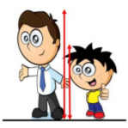
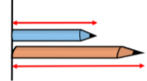
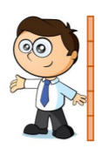
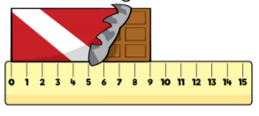
The man is taller than the boy.
The boy is shorter than the man.
The blue pencil is shorter than the red pencil.
The red pencil is longer than the blue pencil.
The man is 5 sticks tall
The chocolate bar is 9 cm long
Measure – Length & Height

