Knowledge
- Volume is the amount of space taken up by a shape
- Capacity is the amount of liquid a container can hold
- We describe volume using the language:
- Full, nearly full
- Empty, nearly empty
- We describe capacity using the language:
- Holds more liquid
- Holds less liquid
- The unit of measurement for volume is:
- Millilitre (ml)
- Centilitre (cl)
- Litre (l)
- Kilolitre (kl)
Vocabulary | Definitions
Volume | The amount of space taken up by a shape
Capacity | The amount of liquid a container can hold
Order | To place items in a sequence from the least to the most or most to the least
Estimate | To make a guess
Measure | To use equipment to check the weight/mass of an object
Scale | The scale is on the measuring equipment

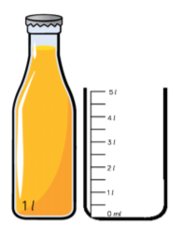
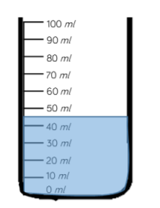
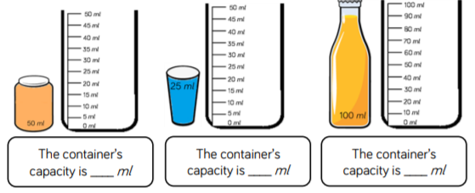
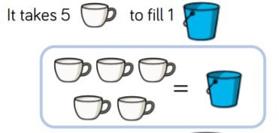
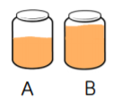
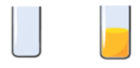
Measure – Volume/ Capacity

The containers capacity is 1 litre
It is between 40ml and 50ml so it is approximately 45 ml
100
25
50
The capacity of the blue bucket is 5 cups
full
empty
B has more liquid than A
A has less liquid than B

