Knowledge
- Weight is the force of gravity on an object
- Mass is the amount of matter inside an object (this is what we measure)
- We describe weight using the language:
- Heavy, heavier, heaviest
- Light, lighter, lightest
- The unit of measurement for length and height is:
- Milligram (mg)
- Gram (g)
- Kilogram (kg)
Vocabulary | Definitions
Weight | The force of gravity on something e.g. how heavy it is
Mass | The amount of matter inside an object
Order | To place items in a sequence from the least to the most or most to the least
Estimate | To make a guess
Measure | To use equipment to check the weight/mass of an object
Scale | The scale is on the measuring equipment

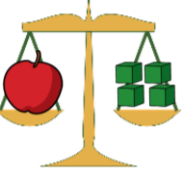
The apple weighs the same as 4 cubes
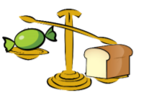
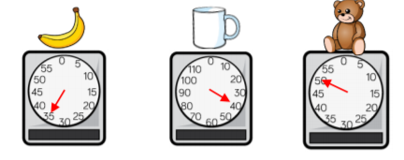
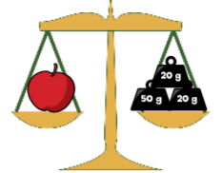
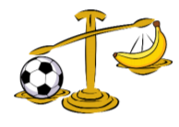
Measure – Weight/ Mass

The loaf of bread is heavier than the sweet.
The sweet is lighter than the loaf of bread
Banana = 35g
Cup = 40g
Teddy = 50g

The apple weighs 90g

The football is heavier than the banana.
The banana is lighter than the football

