Measure  (Length/height /weight/capacity) |  | To order 2 or 3 objects by length/height/weight/ capacity | To use everyday language of length/height/ weight/capacity to compare and describe | To estimate and begin to measure using non standard units | To calculate the difference and describe and compare length/height/ weight/capacity using measurements | To measure and record accurately using standard unit of measurement | Read scales in 2’s,5’s and 10’s | Read scales when not all numbers are given
Skill – Practical/Fluency |  | e.g. ordering 3 objects from shortest to longest by how they look visually  MISCONCEPTION  = length  ↑ ↓ = height | e.g.  Comparing one against the other  The red pen is shorter than the green pen.  The red pen is taller than the green pen  Comparing one against all objects  The yellow pen is the shortest | e.g. measuring using blocks or a non standard item of measurement  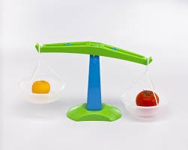 | e.g.  The pencil is 1 block taller than the cotton bud | e.g. length/height  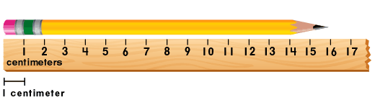  e.g. weight | e.g | e.g
 |  | To order 2 or 3 objects by length/height/weight/ capacity | To use everyday language of length/height/ weight/capacity to compare and describe | To estimate and begin to measure using non standard units | To calculate the difference and describe and compare length/height/ weight/capacity using measurements | To measure and record accurately using standard unit of measurement | Read scales in 2’s,5’s and 10’s | Read scales when not all numbers are given
Vocabulary |  | Object  Length  Height  Weight  Capacity  Order | Language of length  Short/shorter/shortest  Long/longer/longest  Language of height  Short/shorter/shortest  Tall/taller/tallest  Language of weight  Light/lighter/lightest  Heavy//heavier/heaviest  Language of capacity  Full/nearly full/half full  Empty/nearly empty  Holds most/holds least | Length  Height  Weight  Capacity  Estimate  Measure  Object  Long  Short  Tall  Heavy  Light  More  Less | Length  Height  Weight  Capacity  Describe  Compare  Measure  Object  Long  Short  Tall  Heavy  Light  More  Less | Length  Height  Weight  Capacity  Measure  Record  Ruler  Scale  Container  Mm/cm/m  Ml/cl/l  Mg/g/kg | Measure  Length  Height  Weight  Mass  Capacity  Scales  2’s  5’s  10’s  Units of measurement  Mm/cm/m  Ml/cl/l  Mg/g/kg | Measure  Length  Height  Weight  Mass  Capacity  Scales  Units of measurement  Mm/cm/m  Ml/cl/l  Mg/g/kg
Skill – Knowledge  (Address this knowledge through taught input and diagnostic questioning) |  | - Misconception between length and height  - Be able to recognise differences in objects by looking at them | - Understand the corresponding language for each measurement | - Know where to start to measure the object from e.g. the bottom or the end (length/height) | - Understand the ‘difference’ | - Recognise and understand units of measurement and what they stand for | - Count in 2’s, 5’s and 10’s  - Be able to identify which unit of measurement | - Be able to read scales when only estimate points are given
Skill - Evaluation | Evaluate learning through REACH questioning and evidence of mathematical vocabulary in pupil voice and responses

