Money |  | To begin to use everyday language of money | To recognise and know denominations of coins and notes | To be able to compare and describe amounts using language of money | Use knowledge of 2’s, 5’s and 10’s to count in coins | Use coins and notes to make amounts | Finding the total of 2 or more amounts of money | Calculating change
Skill – Practical/Fluency |  | e.g  “I will have 4 buns please.”  “That will 5 pennies.” | e.g.  5p  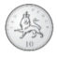 10p  £2 | e.g.  50p 20p  The bus costs more than the dog.  20p is worth more than a 2p  > | e.g.  make 10p using 5p coins  Make 50p using 10p coins | e.g.  make 50p  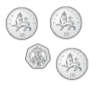  Make £11.15  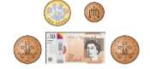  This also includes finding different ways to make the same amounts and finding the most efficient method e.g. using the least amount of coins/notes to make an amount  e.g.  55p in an efficient method is  But could also be done using  50p, 1p, 2p, 2p  Or  20p, 20p, 10p, 5p  Or  10p, 10p, 10p, 10p, 10p, 5p  etc | e.g.  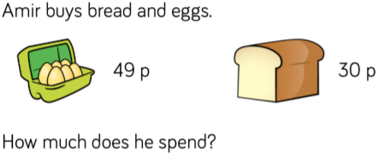  49p + 30p =  ////……… + /// =  /////// = 70  ……… = 9  70p + 9p = 79p  Other skills involving addition and subtraction can be practised in the context of money:  - Finding the difference between two amounts  - Two step problems involving amounts of money | e.g.  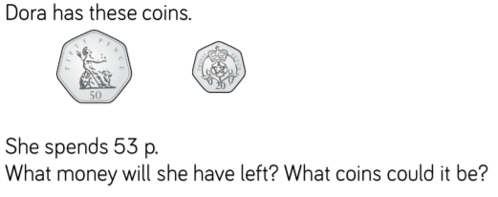  70p – 53p =  ///////  Take away 5 tens  //  Exchange one ten for ten ones  /……….  Take away 3 ones  /…….  70p – 53p = 17p  Then calculate which coins would be the most efficient way to make 17p
 |  | To begin to use everyday language of money | To recognise and know denominations of coins | To be able to compare and describe amounts using language of money | Use knowledge of 2’s, 5’s and 10’s to count in coins | Use coins and notes to make amounts | Finding the total of 2 or more amounts of money | Calculating change
Vocabulary |  | Pounds  Pence  Coin  Note  Penny  Change  Costs | Pounds  Pence  Coin  Note  Penny  Change  Costs  1p  2p  5p  10p  20p  50p  £1  £2  £5  £10  £20 | Pounds  Pence  Coin  Note  Penny  Change  Costs  1p  2p  5p  10p  20p  50p  £1  £2  £5  £10  £20  More  Less  Worth  Compare  Describe | Pounds  Pence  Coin  Note  Penny  Change  Costs  1p  2p  5p  10p  20p  50p  £1  £2  £5  £10  £20  More  Less  2’s  5’s  10’s | Pounds  Pence  Coin  Note  Penny  Change  Costs  1p  2p  5p  10p  20p  50p  £1  £2  £5  £10  £20  More  Less  Amount  Value | Pounds  Pence  Coin  Note  Penny  Change  Costs  1p  2p  5p  10p  20p  50p  £1  £2  £5  £10  £20  More  Less  Amount  Value  Increase  Add  Total | Pounds  Pence  Coin  Note  Penny  Change  Costs  1p  2p  5p  10p  20p  50p  £1  £2  £5  £10  £20  More  Less  Amount  Value  Take away  Subtract  Decrease  Difference
Skill – Knowledge  (Address this knowledge through taught input and diagnostic questioning) |  | - Understand money has a value | - Recognise size and shape of coins to know the difference between them | - Understand more and less  - Understand that a coin is not worth more just because it is bigger in size  - Understand that each coin has a different value and is not just worth ‘1’ e.g. 2 5p coins are worth 10p, not 2 because there are 2 coins | - Be able to count confidently in 2’s, 5’s and 10’s | - Use knowledge of 2’s 5’s, 10’s and 1’s to make amounts | - Understand partitioning  - Use knowledge of partitioning to add two quantities together  - Use knowledge of addition  - Remember to use standard unit of measurement | - Use knowledge of subtraction  - Use knowledge of partitioning  - Using efficient method of making amounts
Skill - Evaluation | Evaluate learning through REACH questioning and evidence of mathematical vocabulary in pupil voice and responses

