Knowledge
- Every piece of money has a value
e.g. each coin and note has a value
- A coins value is not defined by the size
e.g. the largest coin in size does not necessarily have the largest value
- The amount of money that items are worth is called the cost
- The amount of money that is given back after paying for something with more money than the cost is called the change
Vocabulary | Definitions
Pound | A coin that is equivalent to 100 pence
Penny | A coin that is the smallest unit of money
Coin | A small piece of metal that is money
Note | A piece of paper money
Change | The amount of money returned after paying for something
Cost | The amount of money something is worth
Value | The quantity each coin holds is its value
Difference | Between the lowest quantity item and highest quantity item

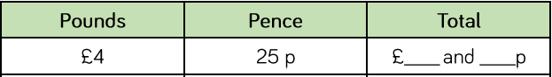
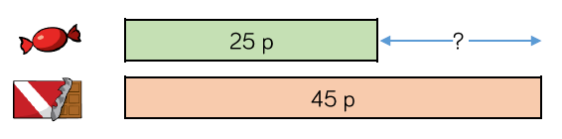
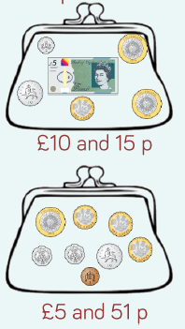
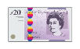
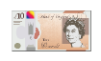
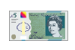
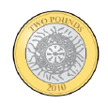
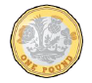
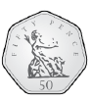
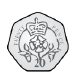
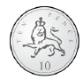
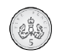
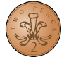
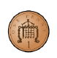
Finding the total
25
4
Finding the difference
Making amounts
£20
£10
£5
£2
£1
50p
20p
10p
5p
2p
1p
Money

