Knowledge
- When we double we add together the same quantity twice.
- Repeated addition is the process of adding the same quantity several times.
e.g. 2 + 2 + 2 5 + 5 + 5 + 5
- An array is a pictorial representation of a repeated addition. Arrays are made up of columns and rows. Each column and row is an equal group. We can use arrays to help solve multiplication problems
- When we multiply two numbers together we are working out how many times we see the same equal group
e.g. oo oo oo oo
2 + 2 + 2 + 2
2, 4 times
2 x 4
Vocabulary | Definitions
Double | Twice the quantity
Equal | Same as
Repeated addition | Equal groups of a number added together e.g. 2 + 2 + 2
Quantity | The value of a number e.g. 3 and 5, 5 is the largest quantity
Lots of/Groups of | Several groups of the same quantity
Array | Arrangement using rows and columns to represent a multiplication
Multiply | Repeated addition  e.g. 2 + 2 + 2 same as 2 x 3
Column | Vertical group within an array
Row | Horizontal group within an array
Product | A quantity created by multiplying 2 quantities together
Factor | A quantity when multiplied with another produces a given number

Multiplication
x

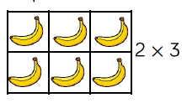
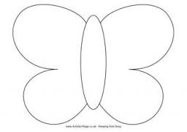
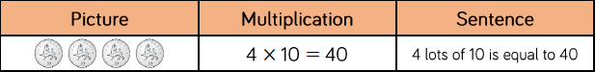
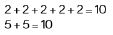
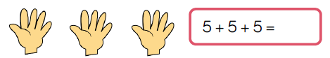
3 x 2
15
Doubling
5 groups of 10
10 + 10 + 10 + 10 + 10
10, 5 times
10 x 5

