Knowledge
- Numbers going from left to right on a number line are increasing/ascending
- Numbers going from right to left on a number line are decreasing/descending
- The crocodile likes to eat the largest quantity so his mouth faces towards the largest quantity.
Vocabulary | Definitions
Number | This is made up of 2 parts (numeral and quantity)
Numeral | Any symbol or word that represents the number (3, three, III)
Quantity | The value of a number e.g. 3 and 5, 5 is the largest quantity
More | The quantity is greater than another
Less | The quantity is fewer than another
Fewer | The quantity is less than another
Increasing | The value of the number is going up
Decreasing | The value of the number is going down
Greater than | The value is more than another value
Equal to | The same as

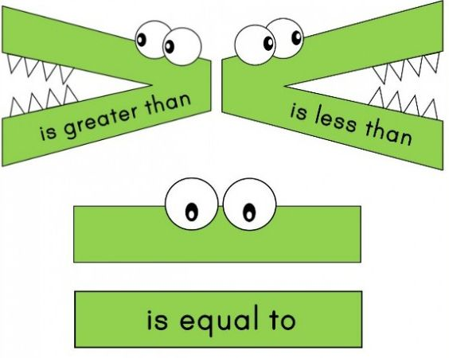

Place Value
Comparing

