Knowledge
- Know numbers can be ordered in ascending or descending order
- E.g. 1, 2, 3, 4 or 4, 3, 2, 1
- A numeral is a physical representation of a number
- Identify a teen number as being made up of a ten and a quantity of ones
- The last digit in a number represents the ones
- The first digit in a number represents the tens (up to 99)
Vocabulary | Definitions
Recite | To repeat out loud
Number | This is made up of 2 parts (numeral and quantity)
Numeral | Any symbol or word that represents the number (3, three, III)
Quantity | The value of a number e.g. 3 and 5, 5 is the largest quantity
Value | The amount a number represents
Recognise | To identify a quantity and recall this from memory
Order | Arranging numbers in a sequence
Tens | How many tens a number has within its value
Ones | How many ones a number has within its value
Pattern | Numbers with a repeated sequence
Ascending | Increasing in quantity
Descending | Decreasing in quantity
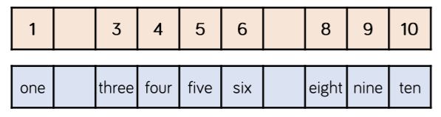
2

Place Value
Recognising and Ordering
Year 1
7

seven
two

