Knowledge
- Quantity represents how much value the number holds e.g. 3 is ooo, 5 is ooooo
- A numeral is a physical representation of a number
- Identify a teen number as being made up of a ten and a quantity of ones
- The last digit in a number represents the ones
- The first digit in a number represents the tens (up to 99)
Vocabulary | Definitions
Match | Being equal in quantity
Number | This is made up of 2 parts (numeral and quantity)
Numeral | Any symbol or word that represents the number (3, three, III)
Quantity | The value of a number e.g. 3 and 5, 5 is the largest quantity
Value | The amount a number represents
Represent | An amount or picture that shows a number
Partition | To divide into parts
Tens | How many tens a number has within its value
Ones | How many ones a number has within its value
Part | An amount that when combined with others makes up the whole
Whole | An amount that is complete in itself

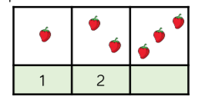
Place Value
Representation

3
