Position and Direction |  | To describe relative position | To use positional and directional language to compare and describe objects | To describe turns | To describe turns including their directionality | To describe position and direction from a starting point | To describe and create patterns using knowledge of turns and direction
Skill – Practical/Fluency |  | e.g.  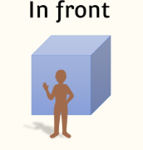 | e.g  The man is in front of the box | 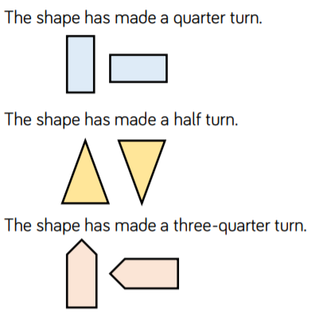  e.g. | e.g.  The triangle has made a half turn clockwise  The triangle has made a quarter turn clockwise | 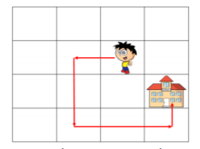  e.g  Move forward 1 square,  Make a quarter turn anticlockwise, move forward 2 squares, make a quarter turn anticlockwise, move forward 2 squares, make a quarter turn anticlockwise, move forward 1 square | e.g.  The rule for the pattern is a half turn clockwise  e.g. Make a pattern where the rule is a quarter turn clockwise
 |  | To describe relative position | To use positional and directional language to compare and describe objects | To describe turns | To describe turns including their directionality | To describe position and direction from a starting point | To describe and create patterns using knowledge of turns and direction
Vocabulary |  | Next to  On top  Behind  In front  Underneath  Over  Between | Next to  On top  Behind  In front  Underneath  Over  Between  Compare  Describe | Full turn  Half turn  Quarter turn  Three quarter turn | Full turn  Half turn  Quarter turn  Three quarter turn  Direction  Clockwise  Anticlockwise | Position  Direction  Move  Forwards  Backwards  Left  Right  Full turn  Half turn  Quarter turn  Three quarter turn  Clockwise  Anticlockwise | Position  Direction  Move  Forwards  Backwards  Left  Right  Full turn  Half turn  Quarter turn  Three quarter turn  Clockwise  Anticlockwise  Compare  Describe  Pattern
Skill – Knowledge  (Address this knowledge through taught input and diagnostic questioning) |  | - Understand placement of objects | - Knowledge of comparative sentence e.g, one object is …… the other object | - Knowledge of halves and fractions to understand the terminology | - Knowledge and understanding of clockwise and anticlockwise | - Knowledge of turns  - Understand the difference between left and right | - To be able to rcreate patterns  - Knowledge of turns
Skill - Evaluation | Evaluate learning through REACH questioning and evidence of mathematical vocabulary in pupil voice and responses

