Knowledge
- Relative position can be described using the following terminology:
- Next to - Underneath
- Inside - On
- In front - Between
- A full turn is made by travelling all the way around and back to the initial starting position
- A half turn is made by travelling half way from the starting point. This means you would be facing in the opposite direction from your starting point
- A quarter turn is made by travelling a quarter of the way from the starting point. A quarter is one fourth of the turn.
Vocabulary | Definitions
Forwards | Move towards the front
Backwards | Move towards the back
Full turn | Travelling all the way around back to the initial starting position
Half turn | Travelling half way from the starting point
Quarter turn | Travelling a quarter of the way from the starting point
Clockwise | In the same direction as which the hands move on a clock
Anticlockwise | In the opposite direction to which hands move on a clock

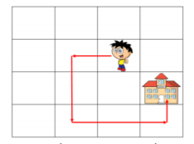
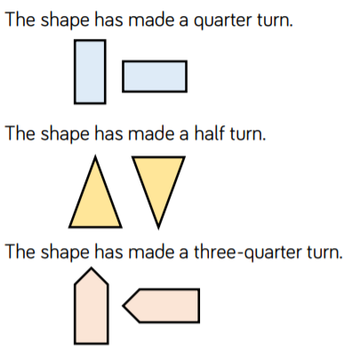
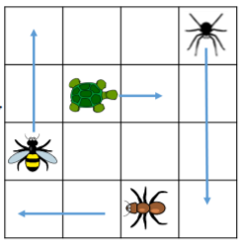
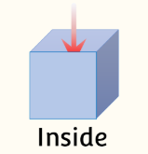
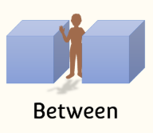
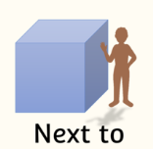
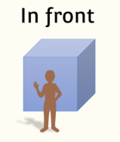
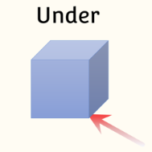
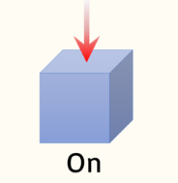
The rule for the pattern is a half turn clockwise

Move forward 1 square, make a quarter turn anticlockwise, move forward 2 squares, make a quarter turn anticlockwise, move forward 2 squares, make a quarter turn anticlockwise, move forward 1 square
The turtle has moved 1 square right
The bee has moved 2 squares up
The spider has moved 3 squares down
The ant has moved 2 squares left
The triangle has made a quarter turn clockwise

The triangle has made a half turn clockwise

Position and Direction

