Shape | Use shapes appropriately for the task | Identify 3D and 2D shapes | Describe 3D and 2D shapes | Lines of symmetry | Describe similarities and differences of shapes
Skill – Practical/Fluency | e.g. when constructing know to use a round block for a wheel on a vehicle  May make some reference to simple shape names | Identify and name a variety of 3D shapes e.g. cube, cylinder, cuboid, cone, pyramid etc  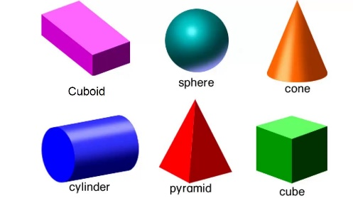  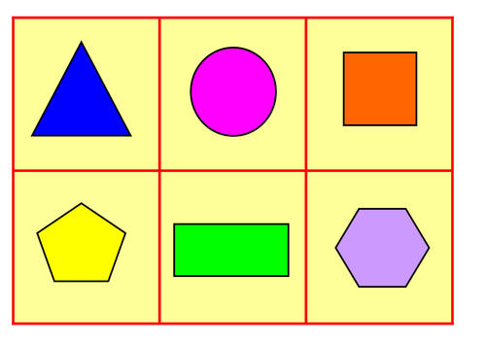  Identify and name a variety of 2D shapes as found on the faces of 3D shapes e.g. circle, square, rectangle, triangle etc | Describe 3D shapes using mathematical terms  Face  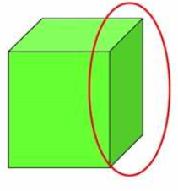  Edge  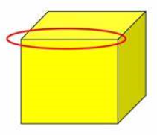  Vertice  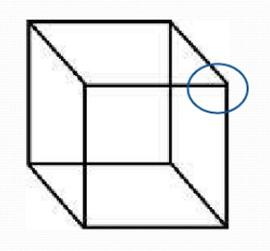 | 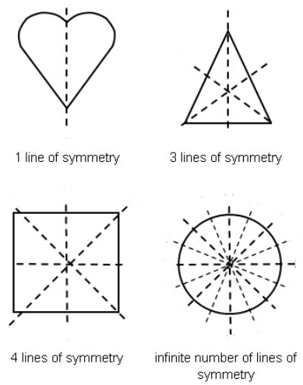 | 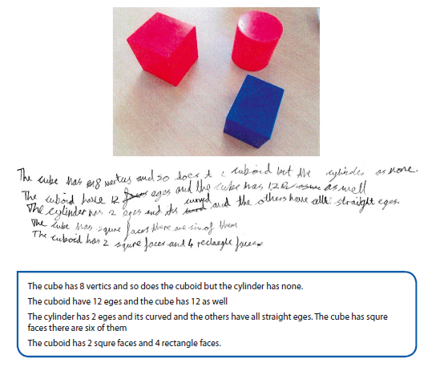  Identifying similarities and differences in shapes  e.g. cuboid and cube have same number of faces, edges and vertices but the faces are different shapes
 | Use shapes appropriately for the task | Identify 3D and 2D shapes | Describe 3D and 2D shapes | Lines of symmetry | Describe similarities and differences of shapes
Vocabulary | Solid  Flat  Round  Pointy | Shape  Solid  Flat  2D  3D  Cube  Cylinder  Cuboid  Cone  Pyramid  Circle  Square  Rectange  Triangle | Shape  2D  3D  Solid  Flat  Cube  Cylinder  Cuboid  Cone  Pyramid  Circle  Square  Rectange  Triangle  Face  Edge  Vertice | Shape  2D  Circle  Square  Rectange  Triangle  Symmetry  Same  Line of symmetry | Shape  2D  3D  Solid  Flat  Cube  Cylinder  Cuboid  Cone  Pyramid  Circle  Square  Rectange  Triangle  Face  Edge  Vertice  Similarity  Difference  Compare
Skill – Knowledge  (Address this knowledge through taught input and diagnostic questioning) | - Awareness of shapes and uses | - Identify difference between a 2D and 3D shape (flat and solid) | - Understanding terminology face, vertice, edge | - Understanding that a line of symmetry is the same as a mirror to show two equal parts | - Understanding of what is same and what is different  - Understanding of properties of all 2D and 3D shapes
Skill - Evaluation | Evaluate learning through REACH questioning and evidence of mathematical vocabulary in pupil voice and responses

