Knowledge
- 2D shapes are 2 Dimensional and this is a flat shape that cannot be picked up or held
- 3D shapes are 3 Dimensional and this is a solid shape that can be picked up and held
- Some names of 2D shapes are circle, rectangle, square, triangle
- Some names of 3D shapes are cube, cuboid, pyramid, cone, cylinder, sphere
- We describe 3D shapes using the terminology faces, edges and vertices
- A line of symmetry is an imaginary line that divides a shape in half
- What is on one side of the line is reflected on the other side of the line.
Vocabulary | Definitions
Solid | A shape that can be held
Flat | A shape that cannot be picked up
2D | 2 dimensional, a flat shape
3D | 3 dimensional, a solid shape
Face | A face is the side of a solid shape
Edge | An edge is where two or more faces meet
Vertices | Vertices are where two or more edges meet
Line of symmetry | A line of symmetry is an imaginary line that divides a shape in half.
Similarity | Characteristics that are the same or similar
Difference | Characteristics that are different

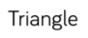
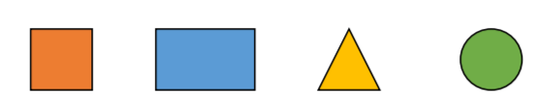
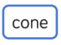
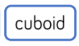
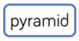
Shape | Name | Number of Faces | Number of Edges | Number of Vertices
 | Cube | 6 | 8 | 12
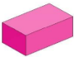 | Cuboid | 6 | 8 | 12
 | Sphere | 1 | 0 | 0
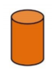 | Cylinder | 3 | 2 | 0
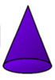 | Cone | 2 | 2 | 1 vertex
 | Pyramid | 4 | 8 | 5
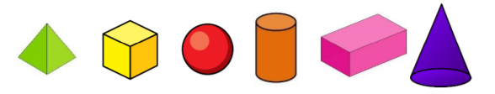
Shape

