Knowledge
- When we look at data and statistics we are looking at a diagram that represents different quantities
- The different types of charts and diagrams we will look at are:
- Tally chart
- Pictogram
- Block diagram
Vocabulary | Definitions
Statistic | A piece of data collected from a study
Data | A set of statistics collected together
Quantity | The value of a number e.g. 3 and 5, 5 is the largest quantity
Total | The final quantity when all groups have been added together
Tally chart | A type of chart to represent the data. One tally (one line represents one quantity)
Key | This shows the quantity that one picture represents
Pictogram | A type of diagram to represent the data. It uses pictures to represent quantities
Block Diagram | A type of diagram to represent the dara. It uses tall and short blocks to represent the quantities

Statistics

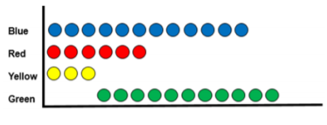
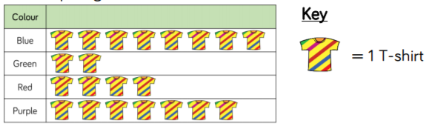
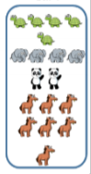
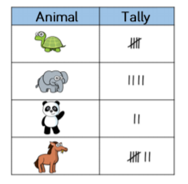
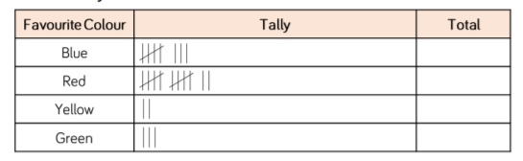
The most popular colour sweet is blue.
The least popular colour sweet is yellow.
Three more people prefer red coloured sweets rather than yellow coloured sweets.
Pictogram
Tally Chart
2
8
12
3

