Knowledge
- A group changes in quantity when something is taken away from it
- Subtraction you only start with 1 quantity (1 group). This is always the largest quantity/group
- Count back from the largest quantity to take away the smaller quantity
- Find the answer
- When subtracting on a number line the starting quantity is plotted at the end of the number line
- If you need to cross the boundary you need to exchange up or down:
- Exchanging up – exchanging ten ones for a ten
- Exchanging down – exchanging a ten for ten ones
Vocabulary | Definitions
Subtract | Taking one group away from another
Fewer | Less
Quantity | The value of a number e.g. 3 and 5, 5 is the largest quantity
Decreasing | The number is going down in quantity
Partition | To divide into parts
Tens | How many tens a number has within its value
Ones | How many ones a number has within its value
Exchanging | Exchanging a ten for ten ones or ten ones for a ten

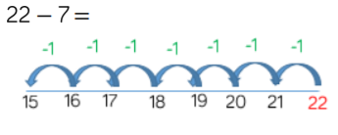
e.g. 9 - 4 e.g. 21 - 5
Subtraction
-
e.g. 27 – 5

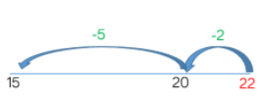
e.g. 11 - 3 1 ten needs exchanging for
10 ones in order to exchange down
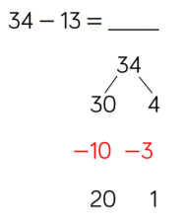
10 10 2
11 – 1

10 – 2
7 - 2

