Knowledge
- The long hand is the minute hand
- The short hand is the hour hand
- O’clock is when the minute hand points at 12
- Half past is when the minute hand points at 6
- The hour hand will be half way in between two numbers when the clock is at half past an hour
- Quarter past is when the minute hand points at 3
- Quarter to is when the minute hand points at 9
- 5 minute intervals are measured from one number to another e.g. 1 to 2, 2 to 3, 3 to 4.
- 5 past is when the minute hand points to 1
- 10 past is when the minute hand points to 2
Vocabulary | Definitions
Past | Already happened
Present | Happening now
Future | Yet to happen
Clock | A device that tells the time
O’ clock | When the long hand points to 12
Half past | When the long hand points to 6
Quarter to | When the long hand points to 9
Quarter past | When the long hand points to 3
Hands | These are the two parts of the clock that move to tell the time
Hour | A measurement of time, equal to 60 minutes
Minute | A measurement of time, equal to 60 seconds
Second | A measurement of time. There are 60 seconds in a minute

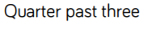
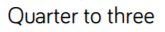
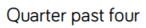
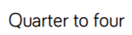
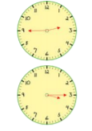
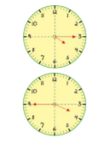
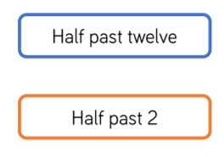
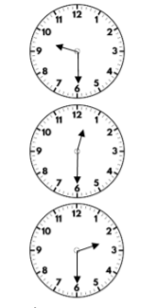
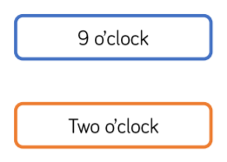
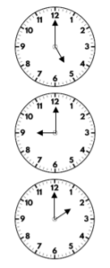
Time

